**LAB REPORT**

**Software Project Management**



**Student Name:** Nguyễn Văn Minh

**ID:** 22003405

**Class:** DHKTPM18

**Course:** 2025-2026

Contents

Module 1: 3

Exercise 1: Creating a link 3

4

Exercise 2: Setting duration 5

Exercise 3: Creating phases 7

Exercise 4: Noah - Linking 9

Exercise 5: Pyramid - Multi level grouping 11

Exercise 6: Creating a plan for Staff Training 13

Exercise 7: Recurring Tasks 15

Exercise 8: Travelling – tasks calendar 16

Module 2: 19

Exercise 1: 19

Exercise 2: 22

Exercise 3: example 25

Exercise 4: example 25

Exercise 5: example 26

Exercise 6: example 26

Module 3: 26

Exercise 1: example 26

Exercise 2: example 26

# Module 1:

## Exercise 1: Creating a link

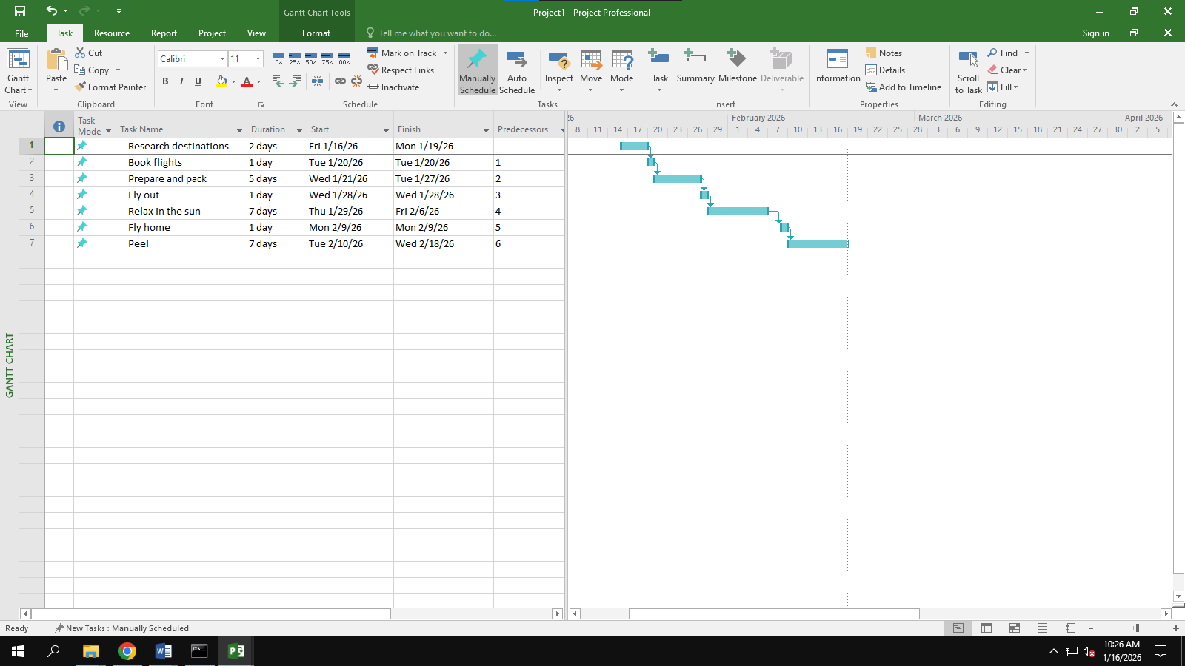

## 

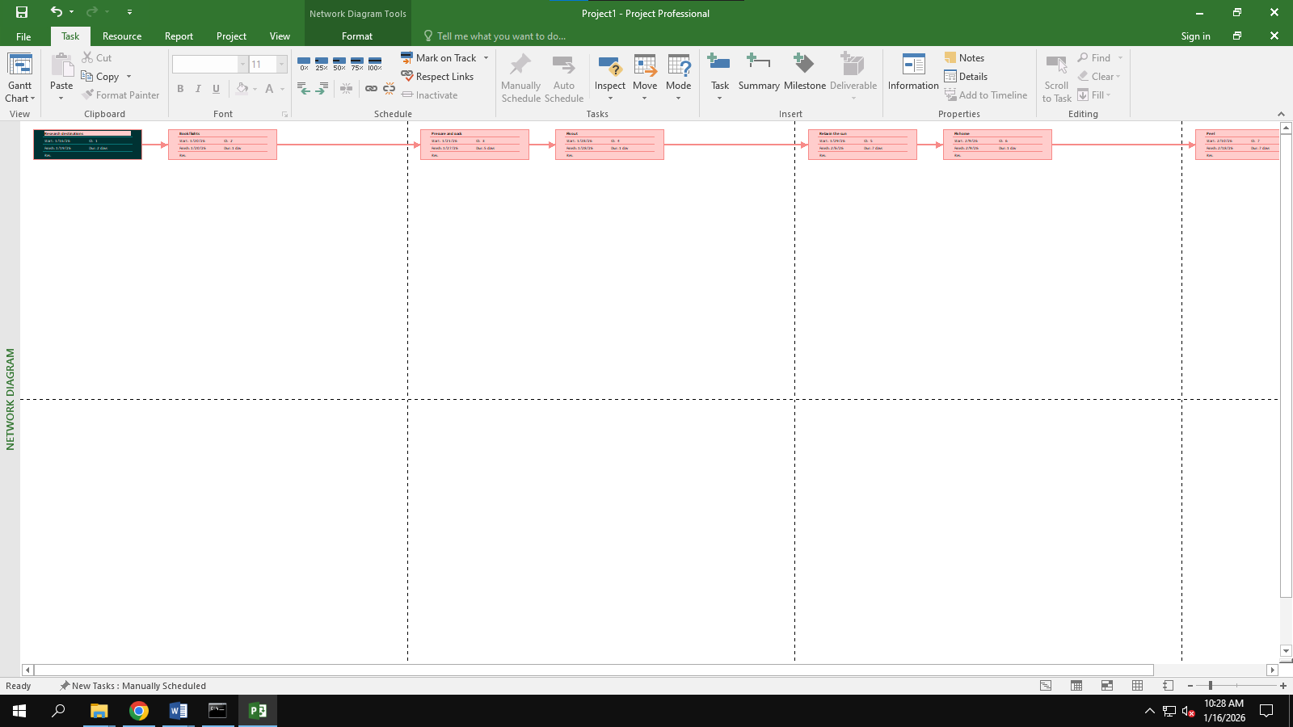

## Exercise 2: Setting duration

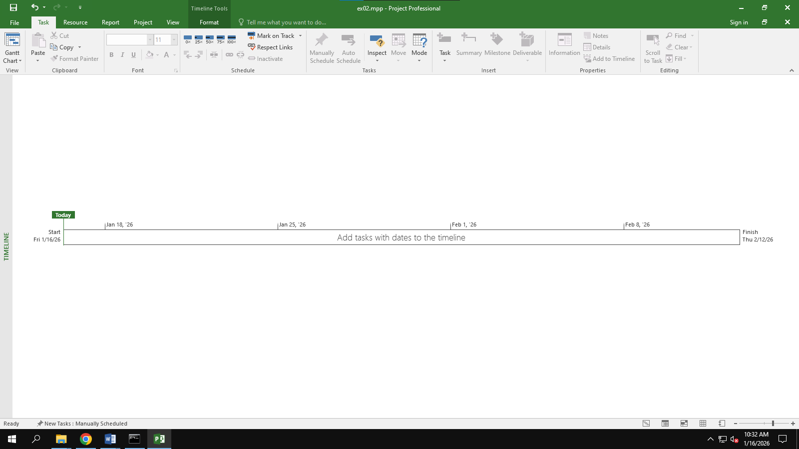

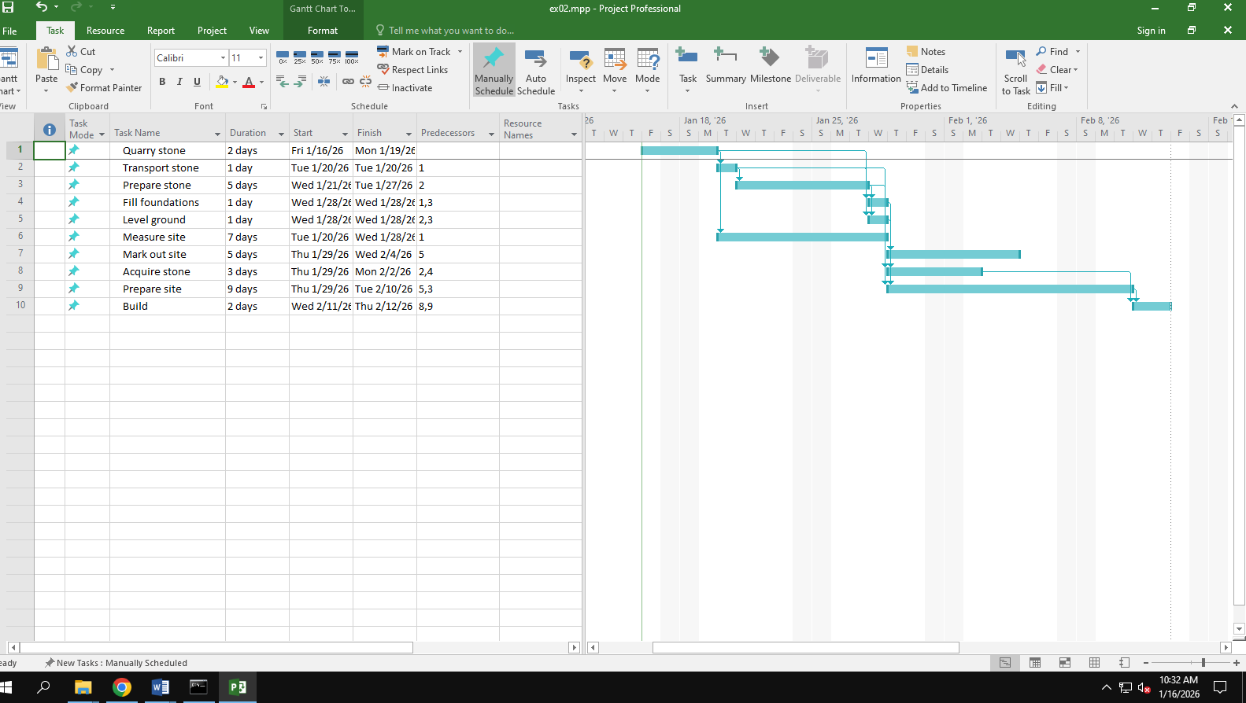

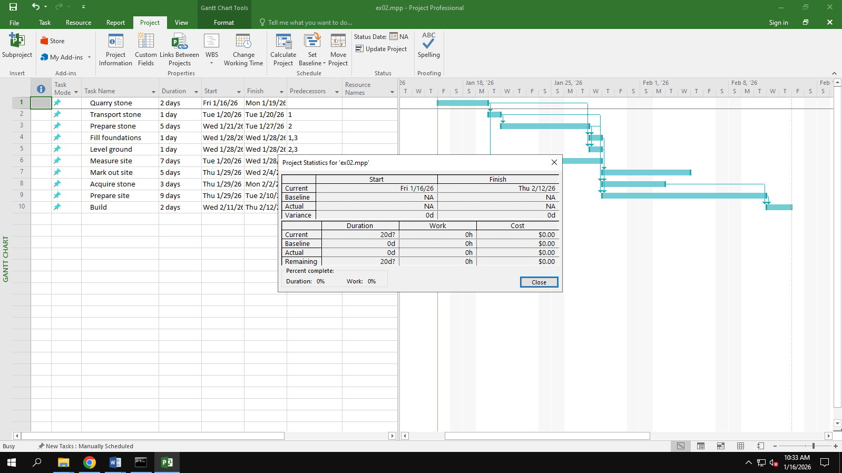

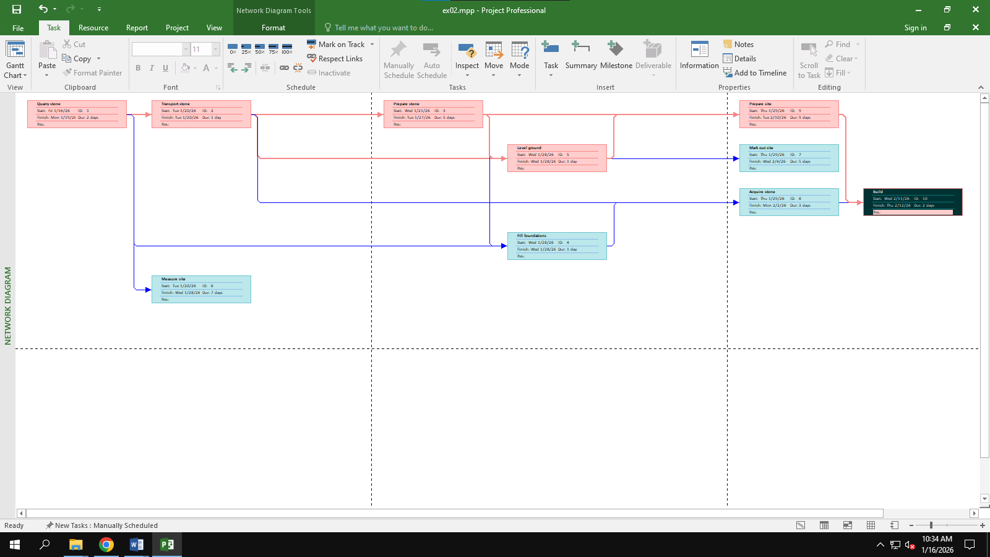

## Exercise 3: Creating phases

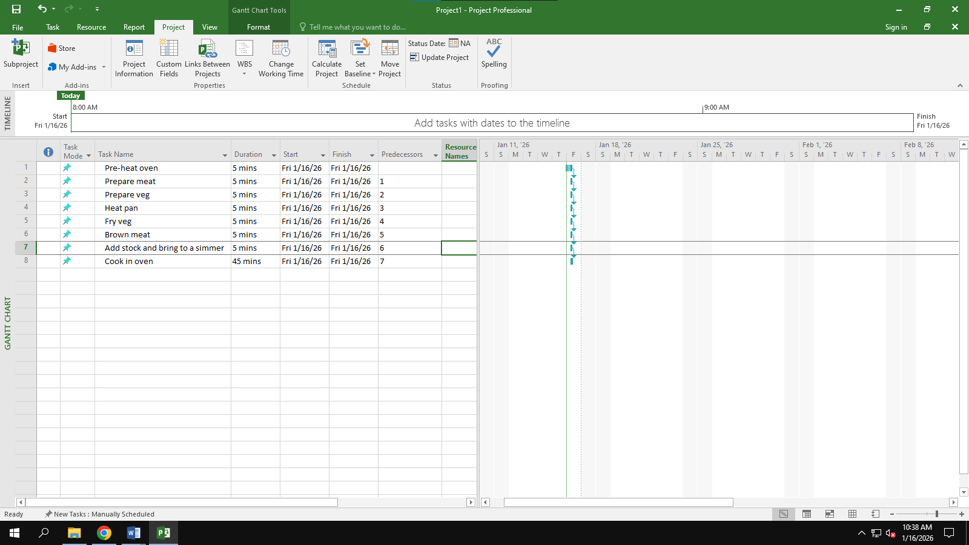

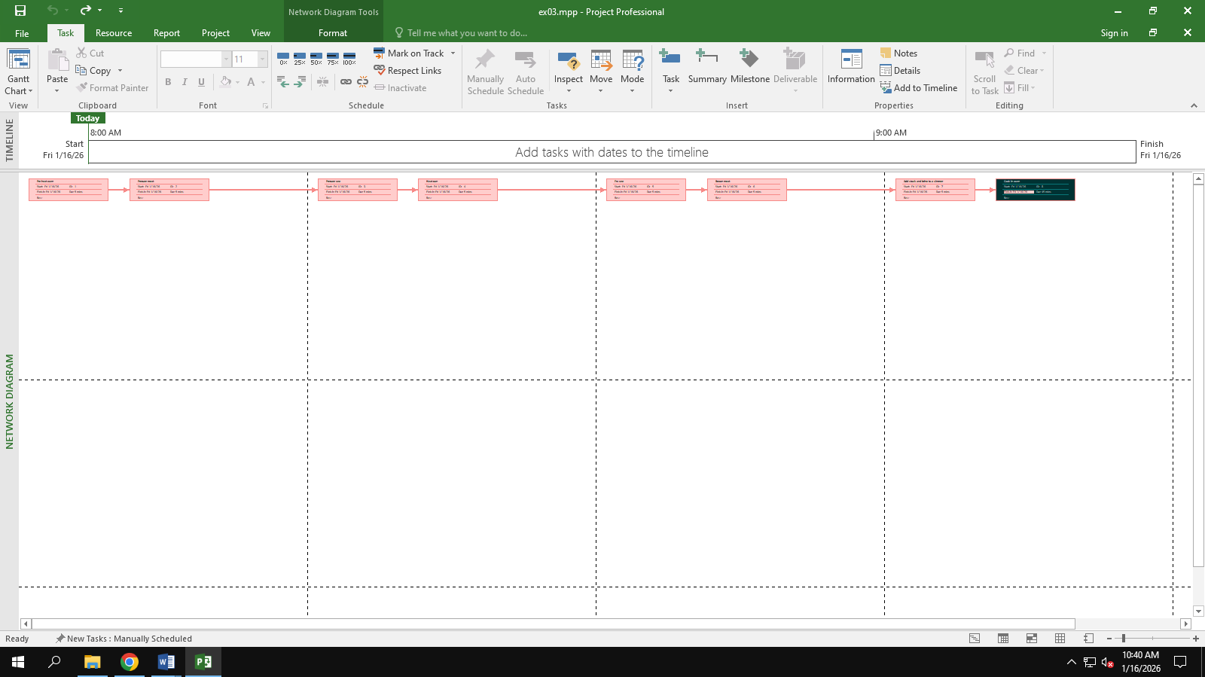

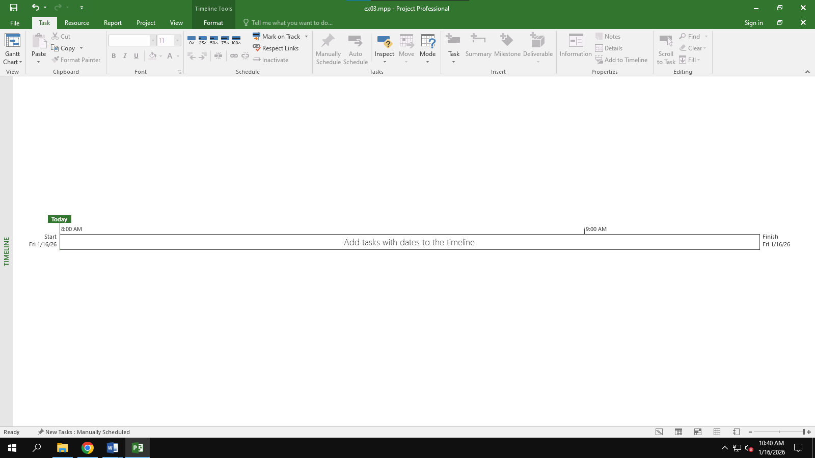

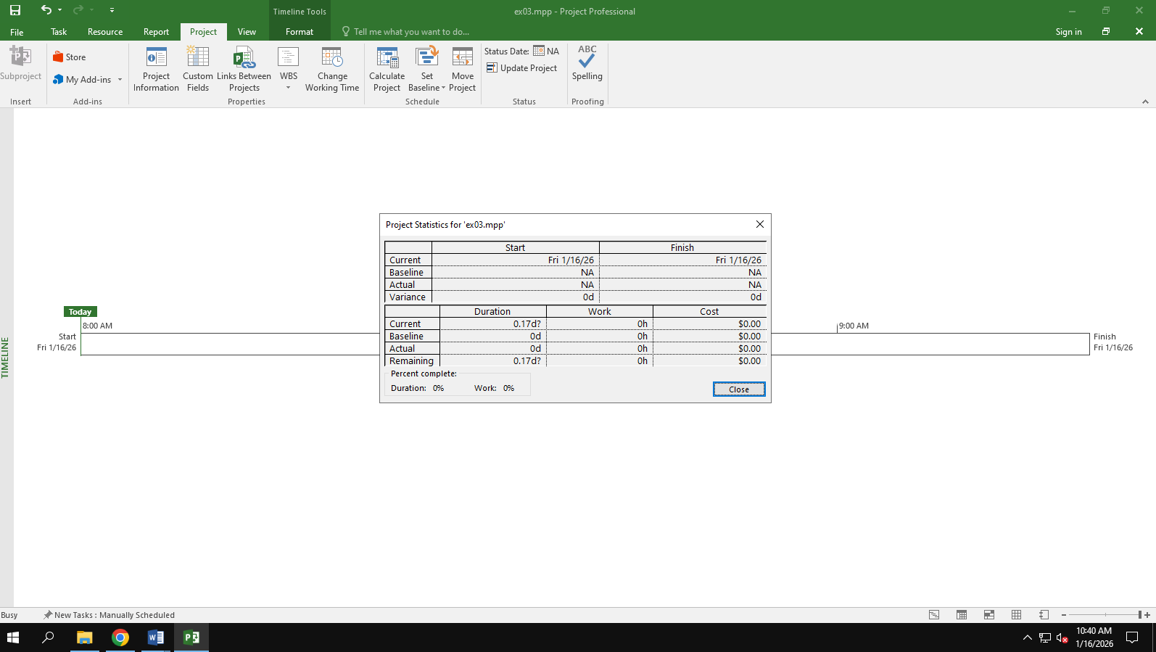

## Exercise 4: Noah - Linking

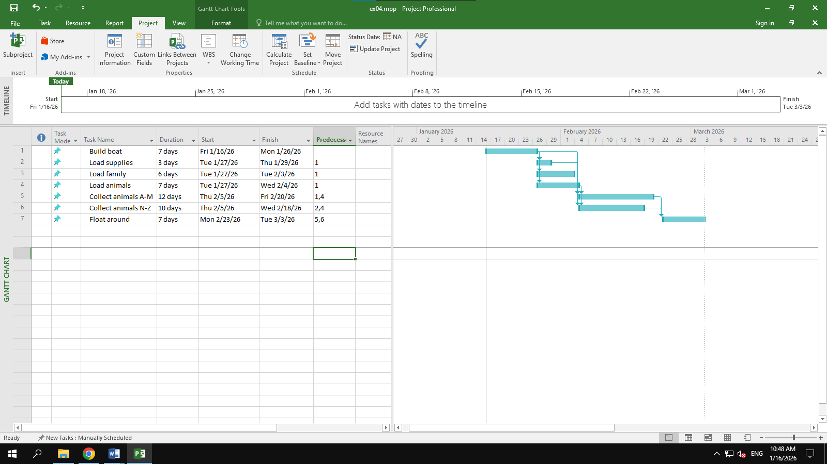

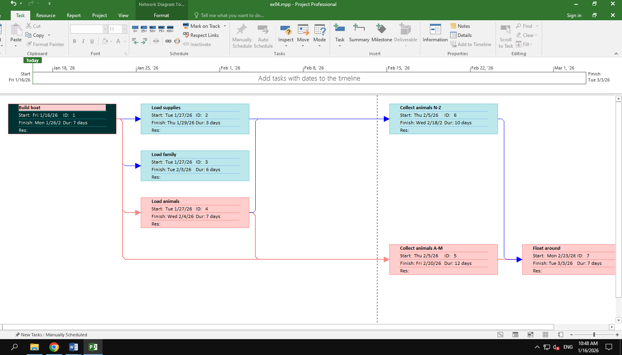

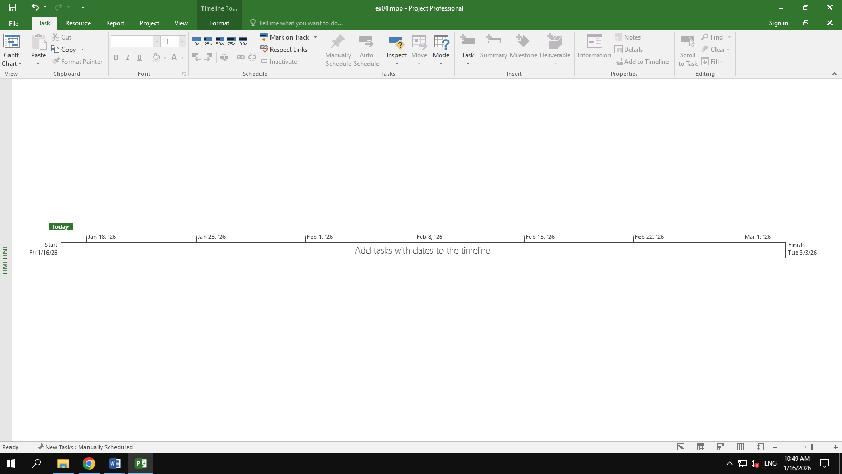

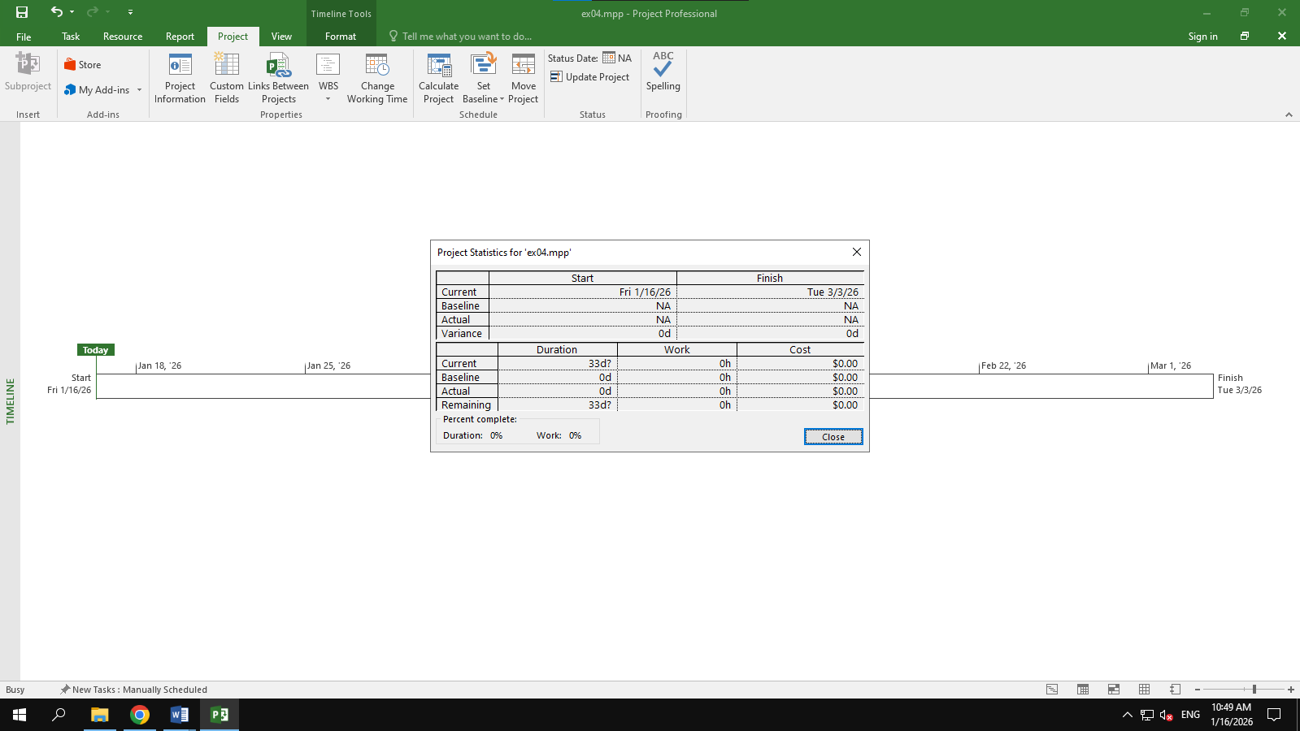

## Exercise 5: Pyramid - Multi level grouping

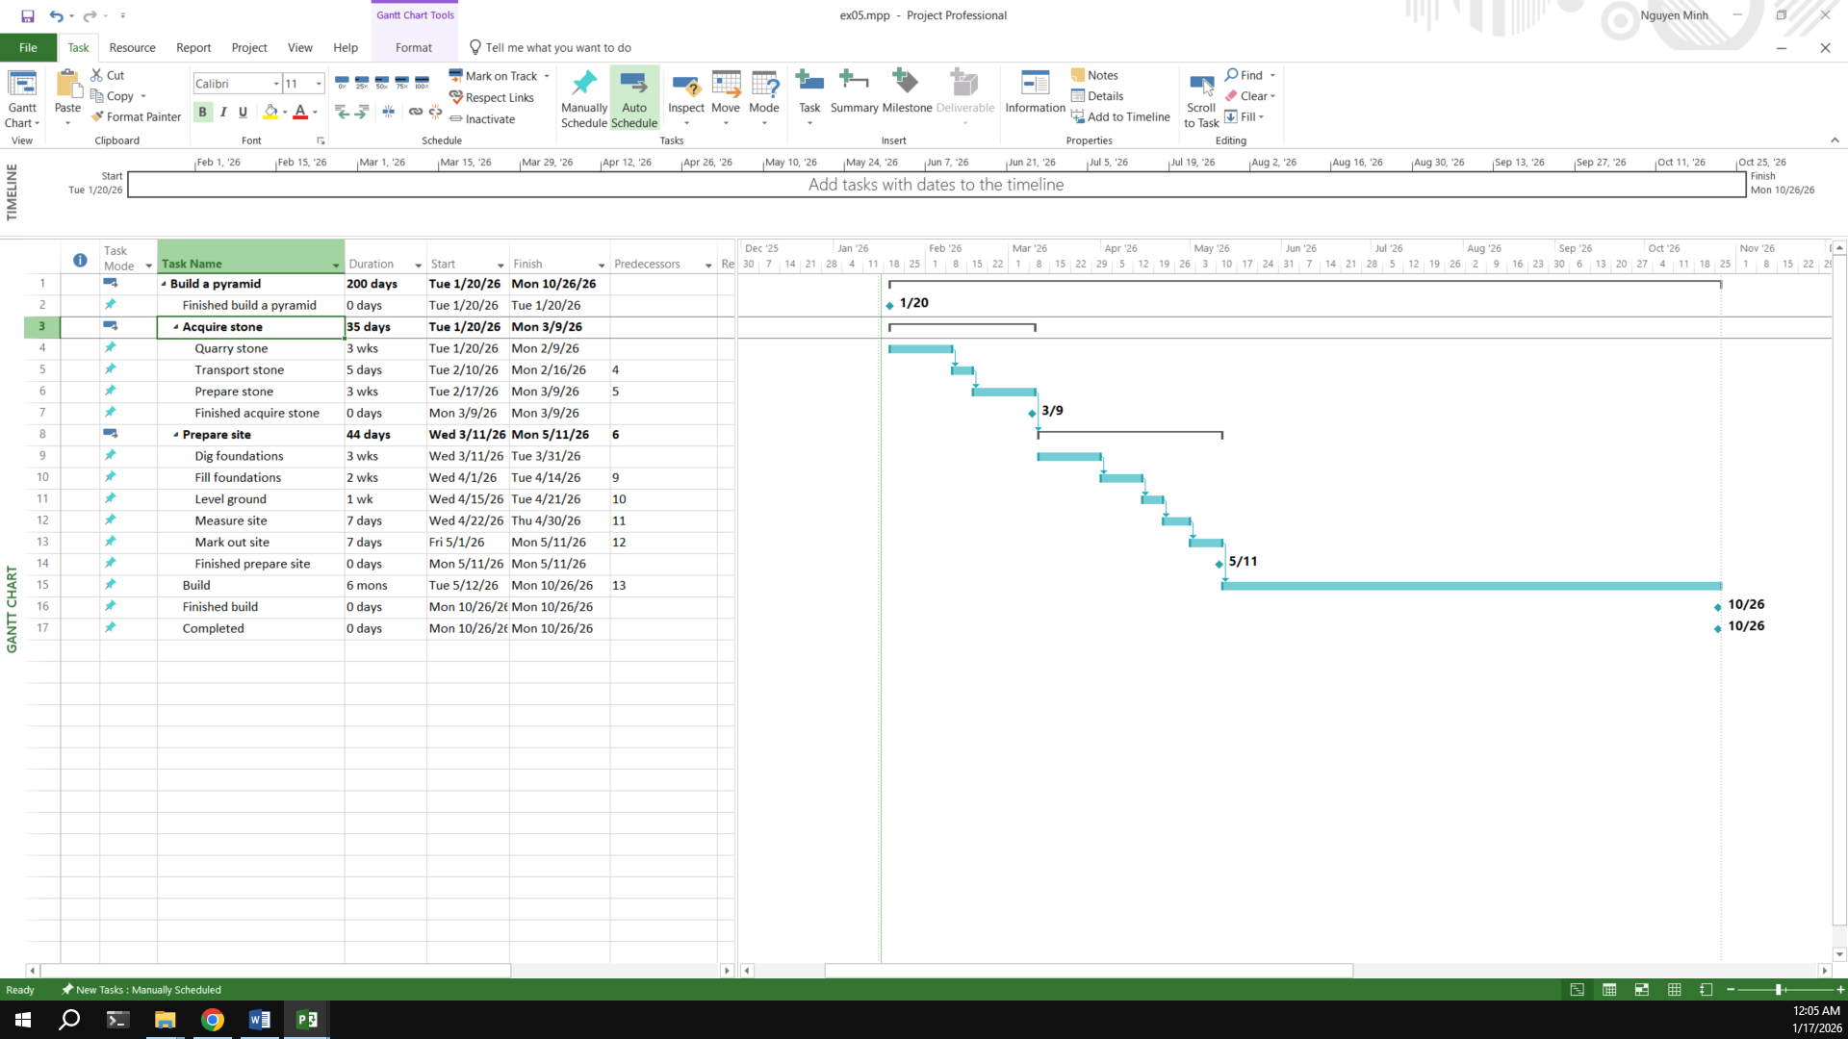

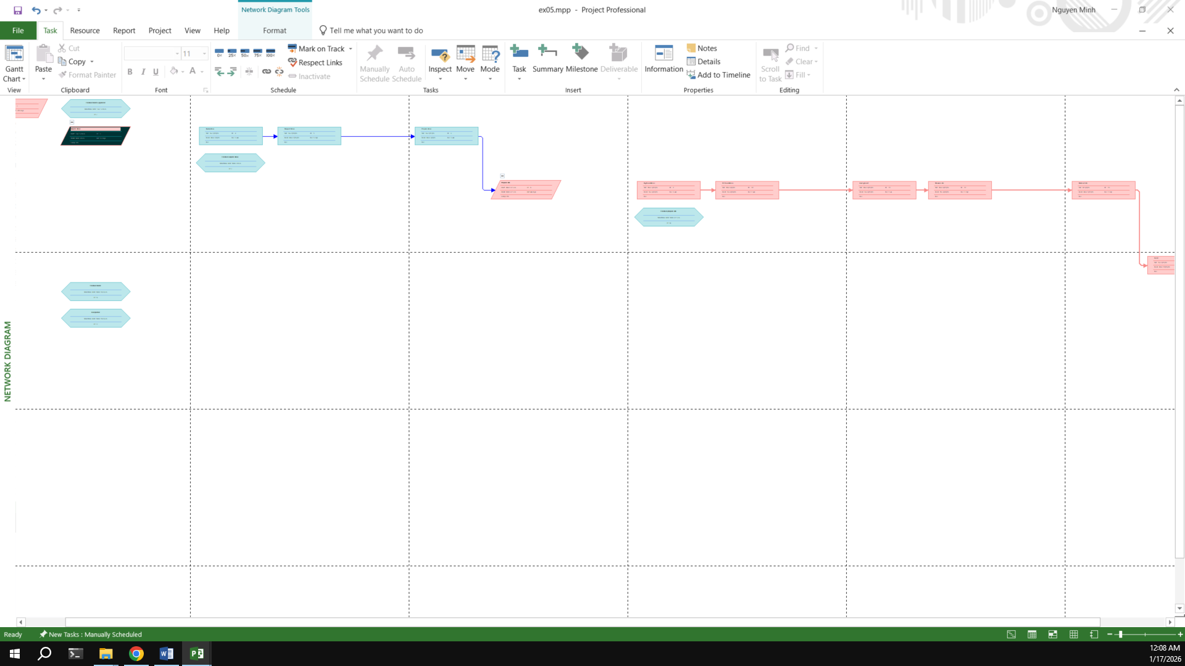

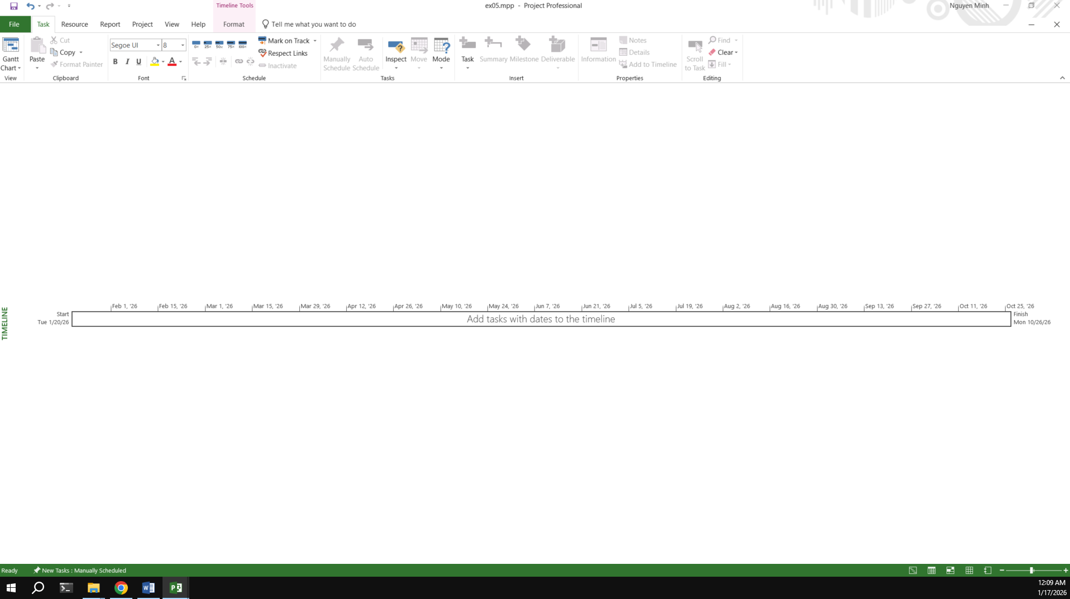

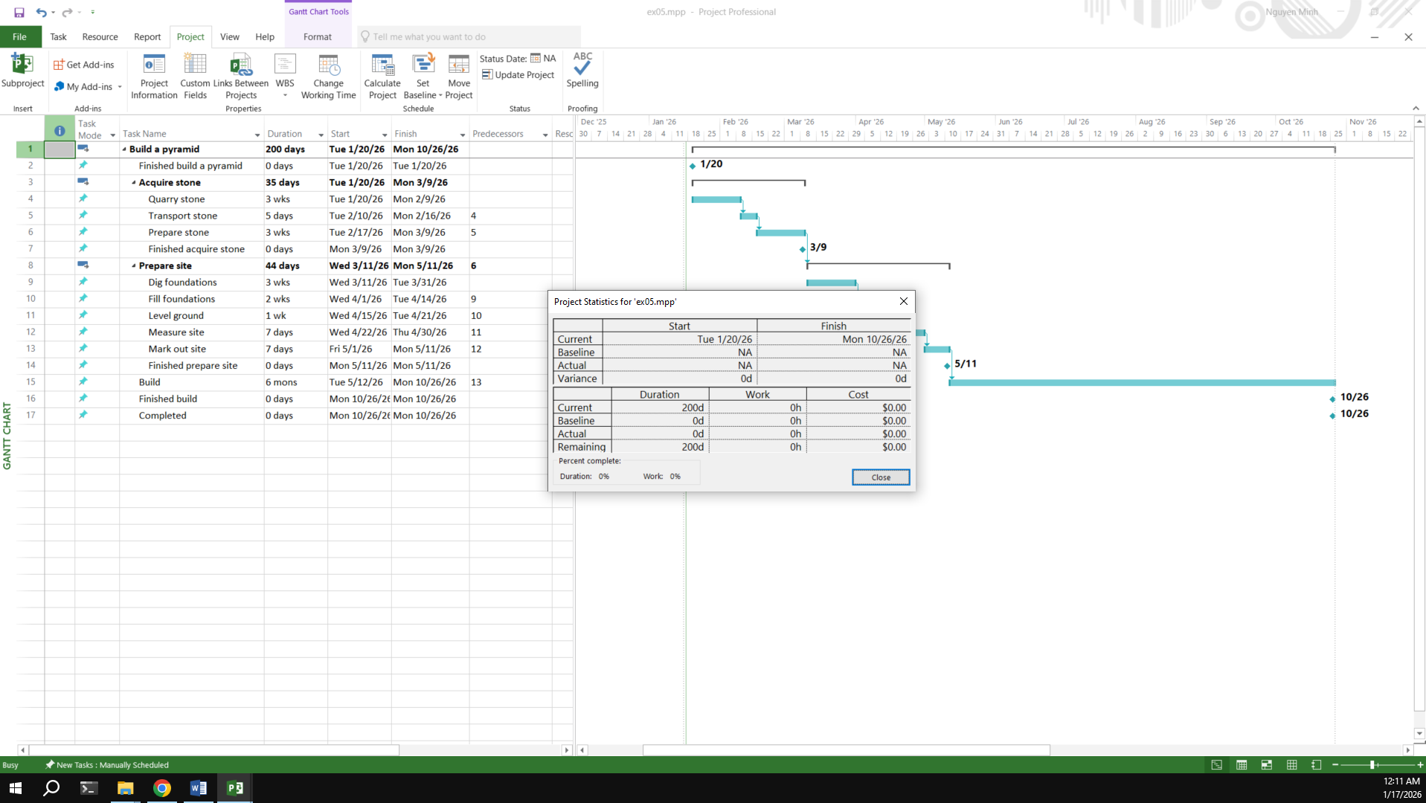

## Exercise 6: Creating a plan for Staff Training

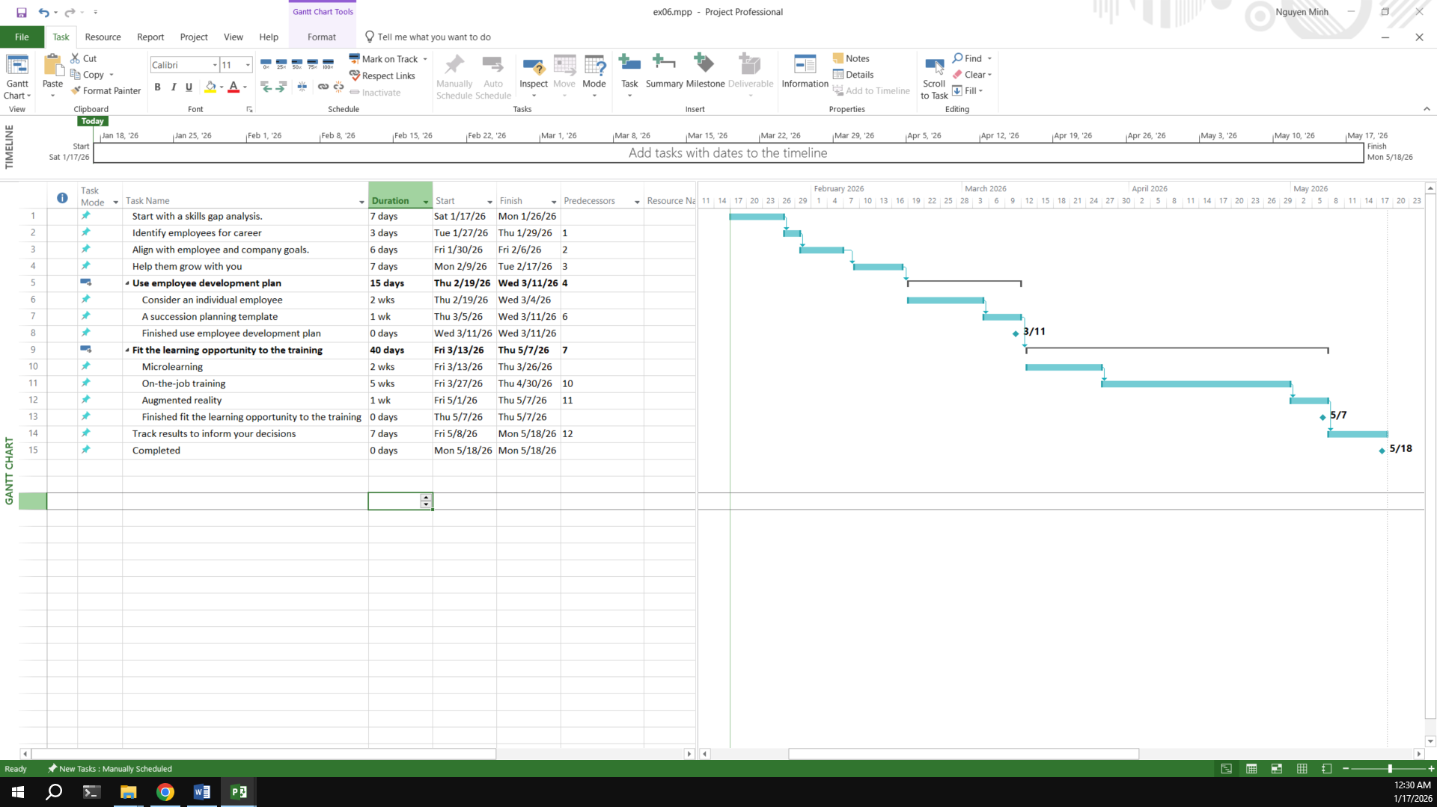

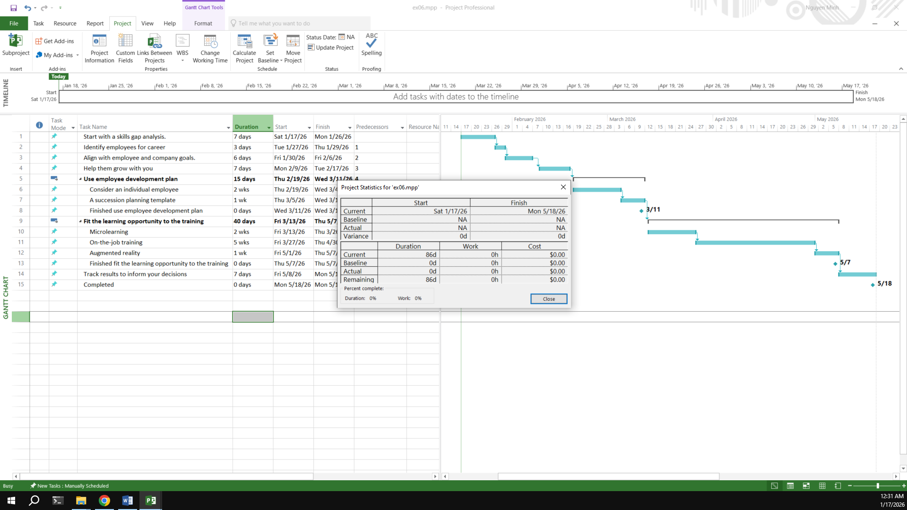

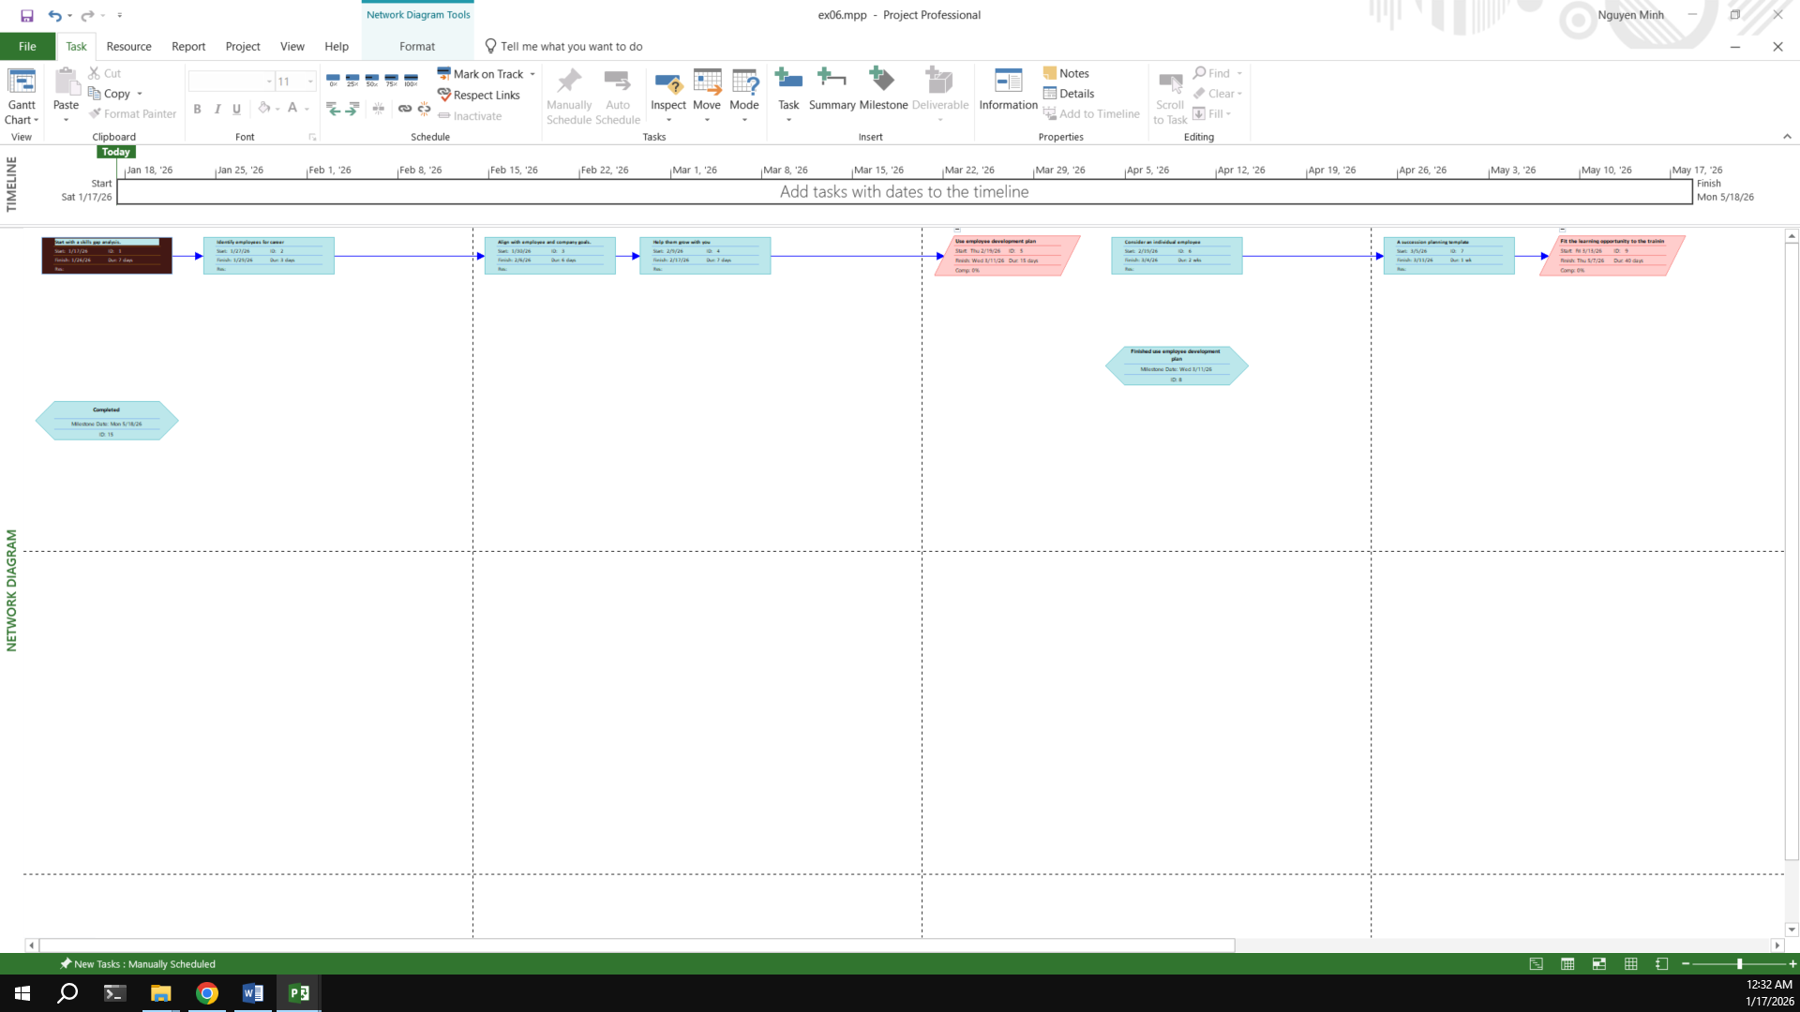

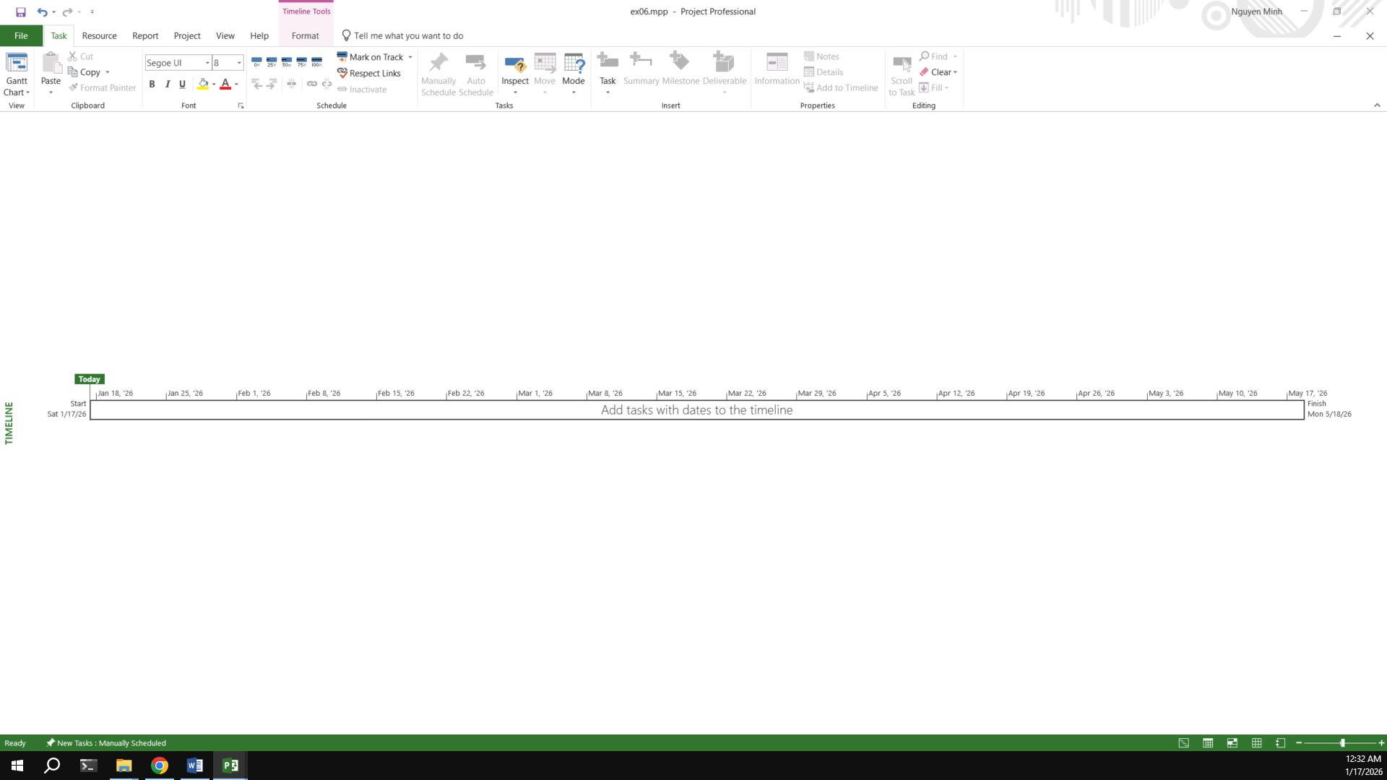

## Exercise 7: Recurring Tasks

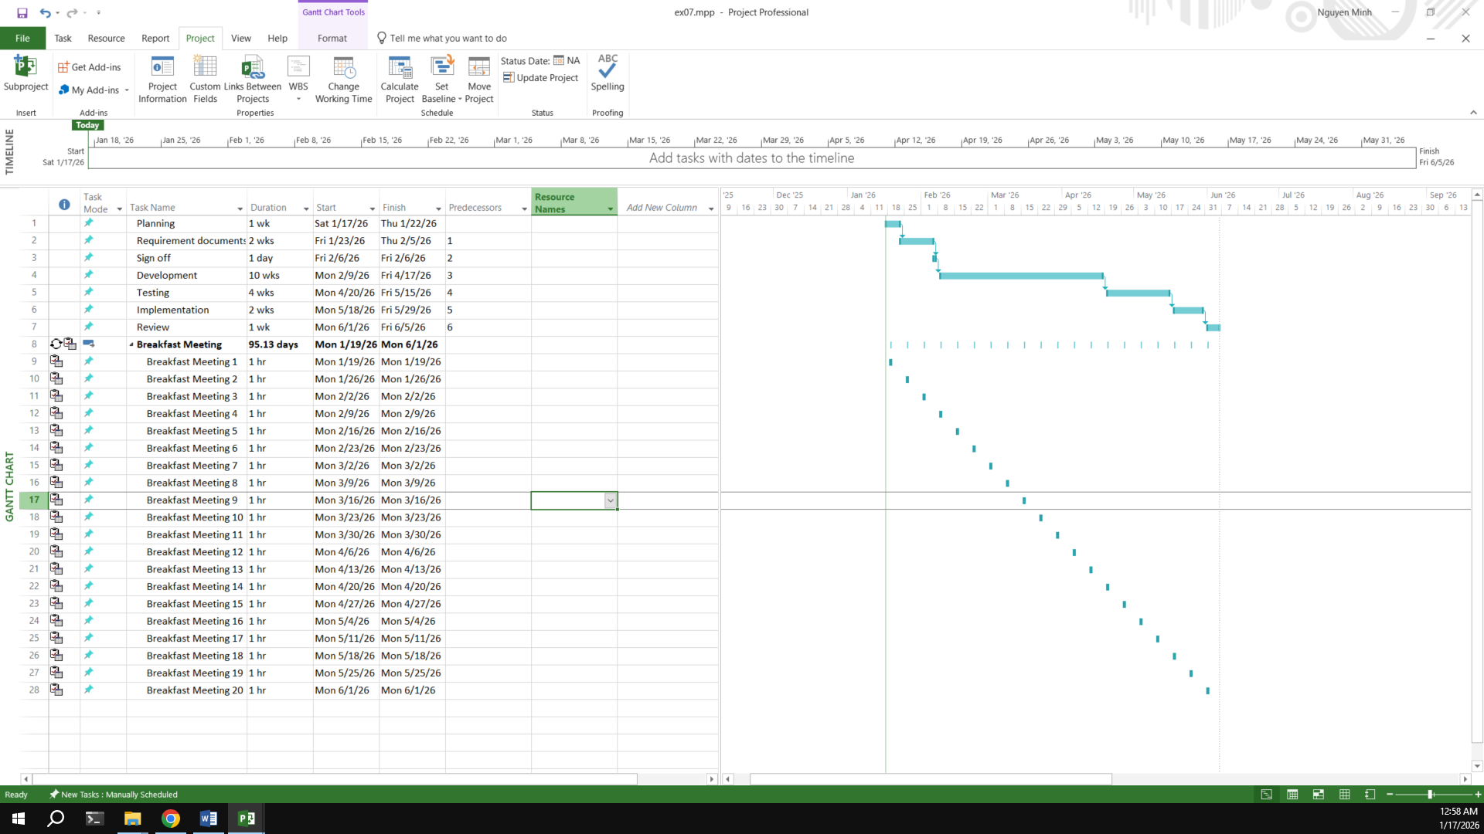

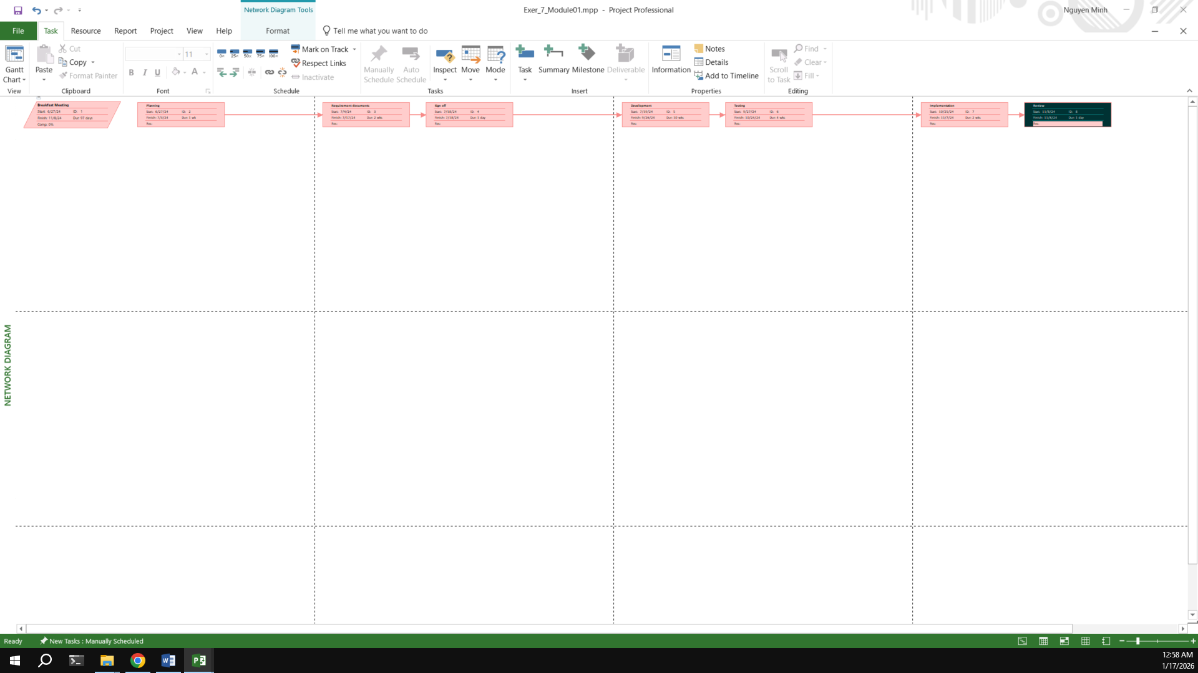

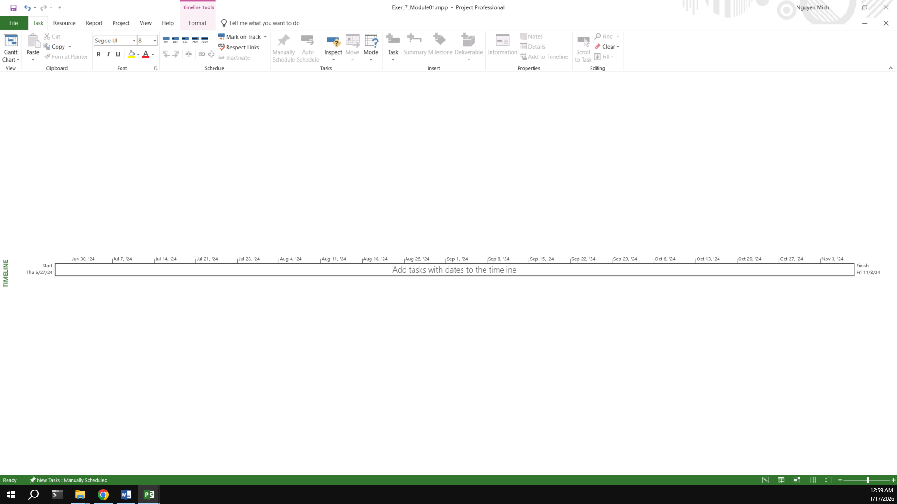

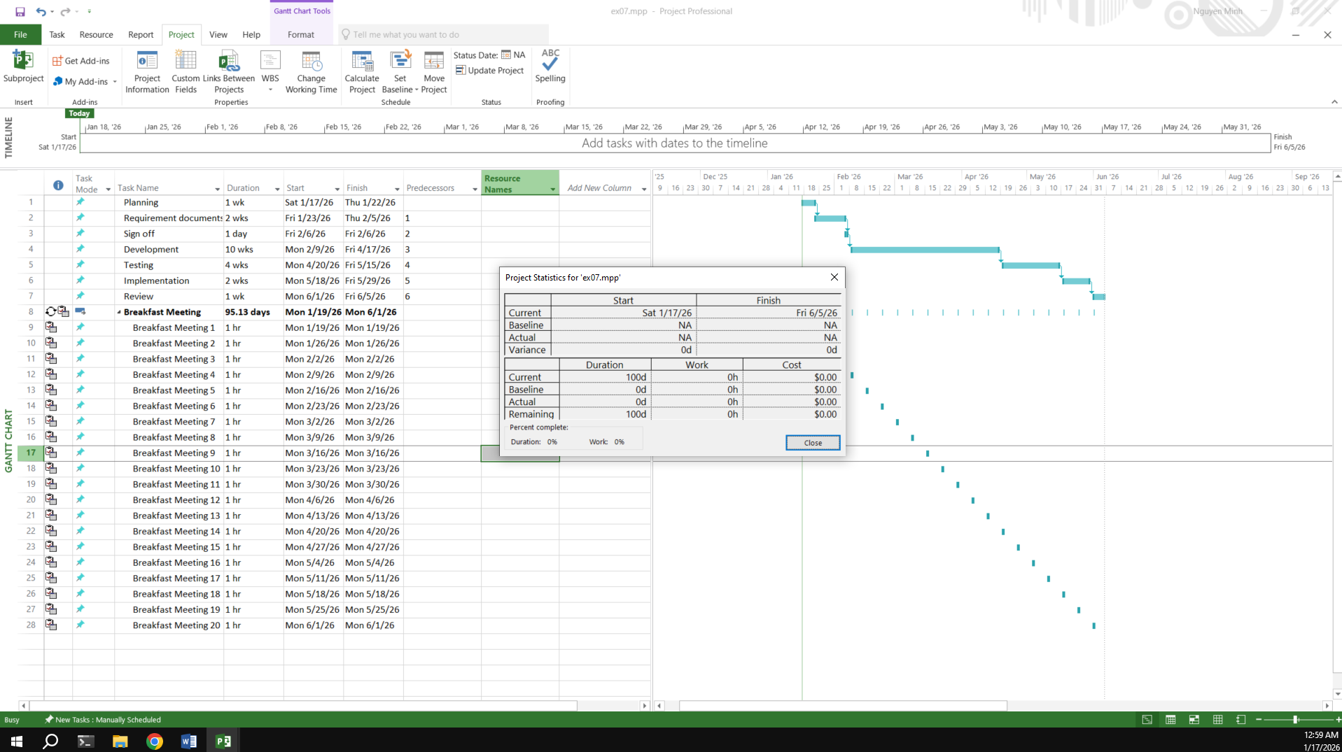

## Exercise 8: Travelling – tasks calendar

Travelling – task calendar You intend to travel from HCM to Kuala Lumpur, Bangkok and then, come back to HCM. Creating a plan for your trip.

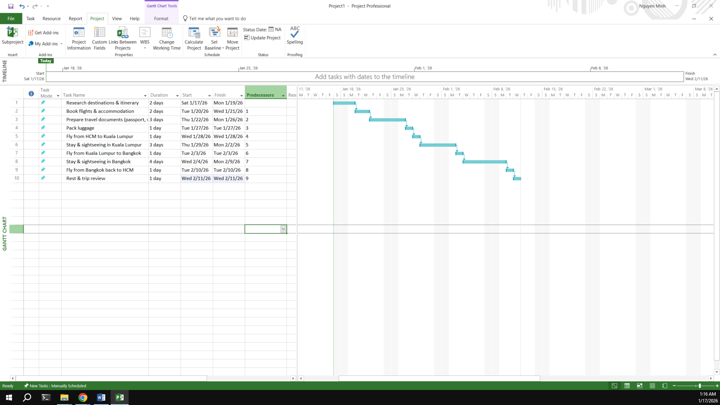

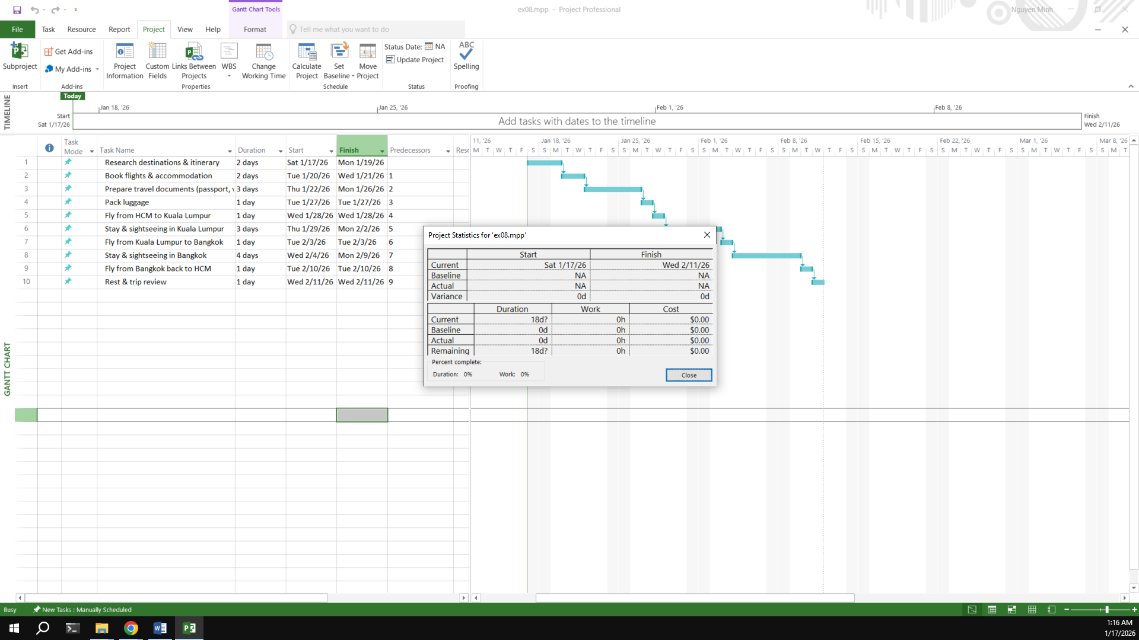

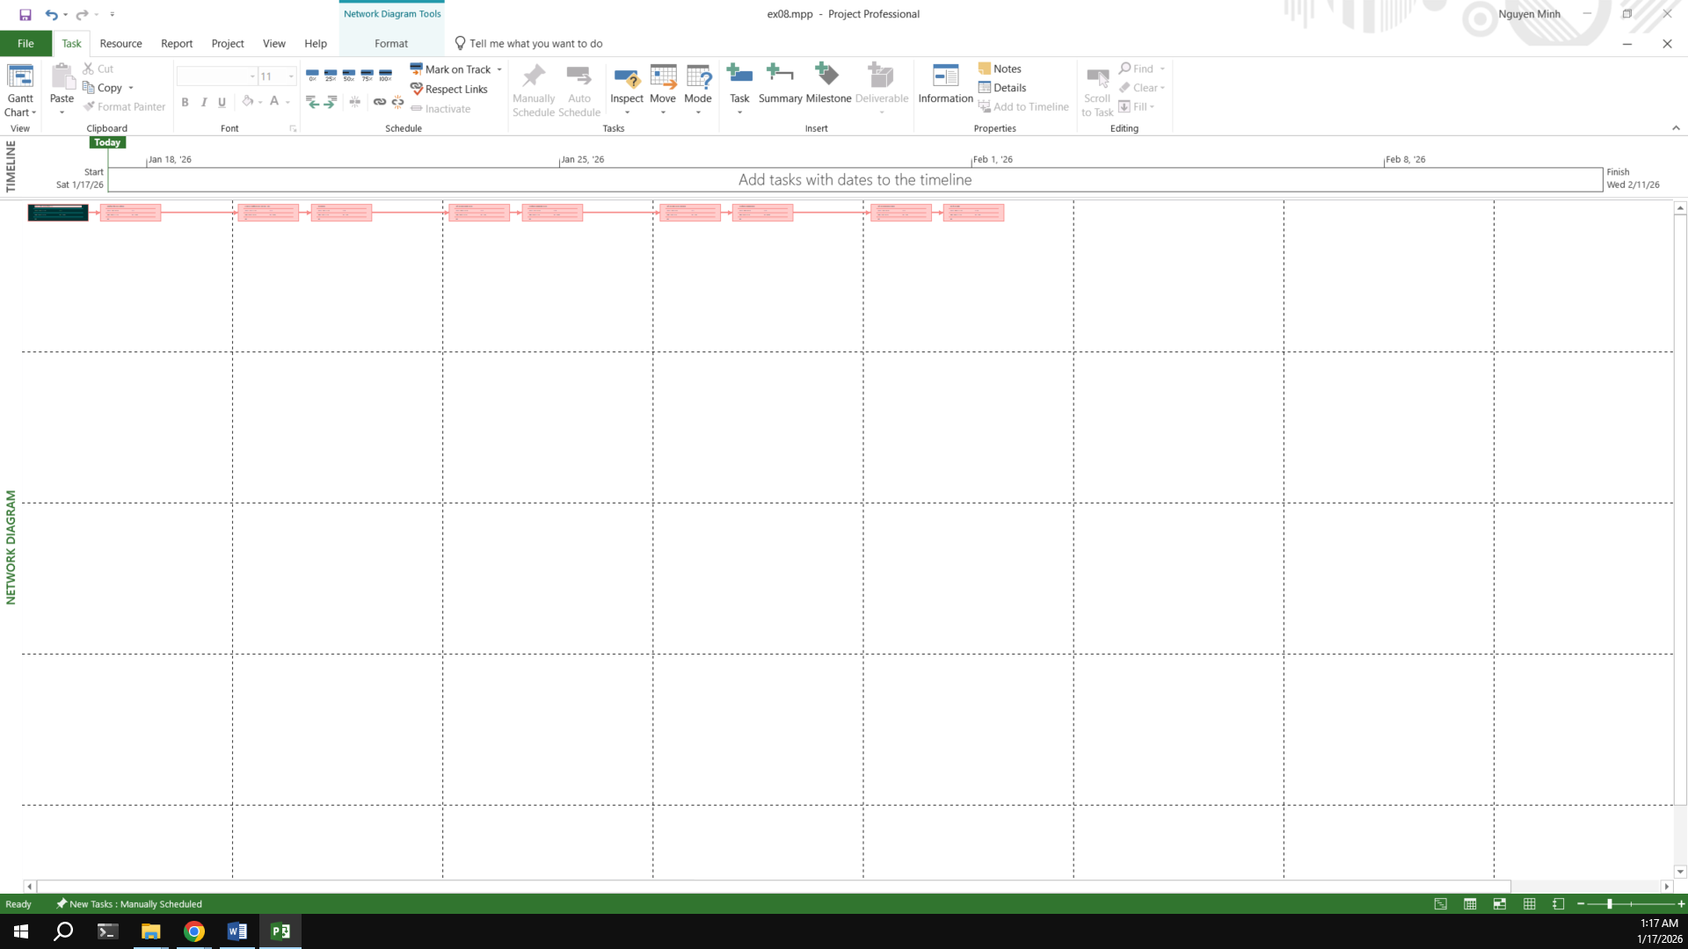

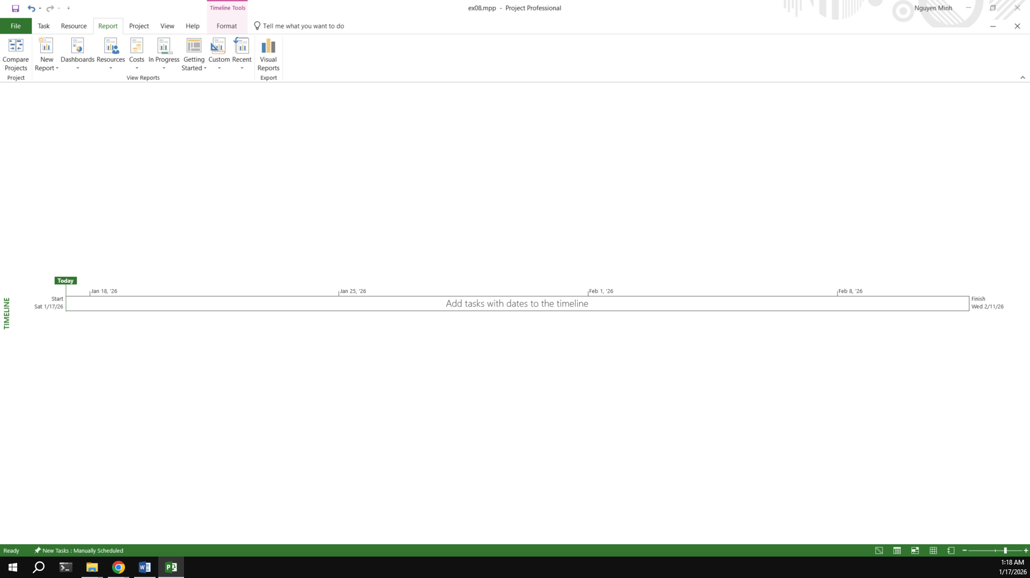

**- End Module 01 -**

# Module 2:

## Exercise 1:

**Part Time - creating new calendar   
Open project file Ex2 (Module 1), Use the Project Information dialog box to:**

A part-time worker will be used on this project. Go to the Change Working Time dialog box and create a new copy of the Standard calendar, calling it "Part Time".

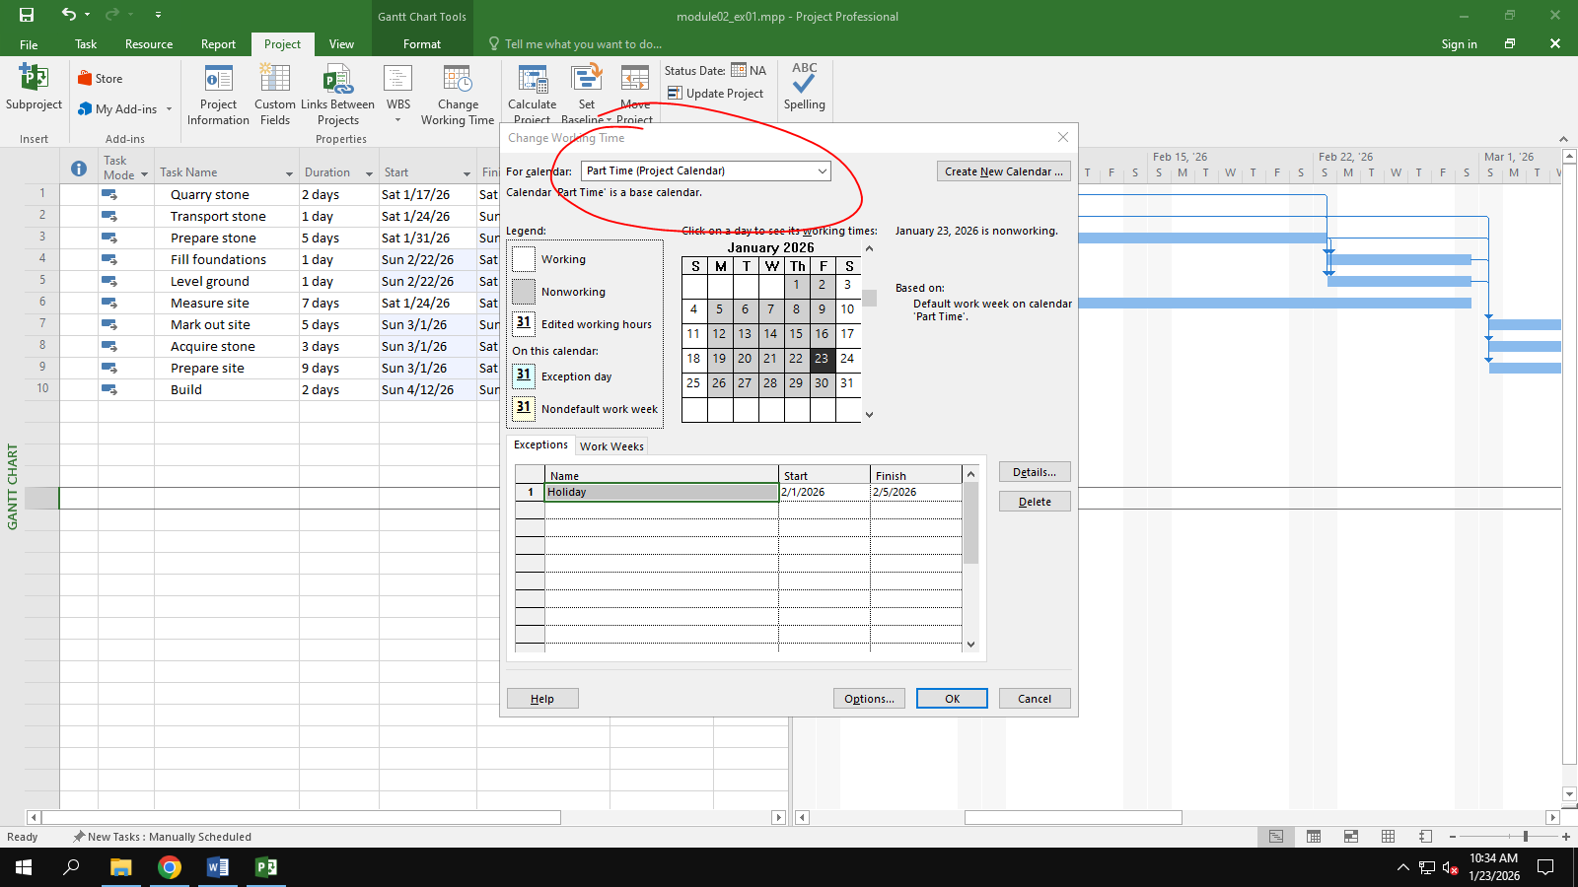

Update the working time of your new calendar so that:   
¬ Mondays to Fridays are nonworking time   
¬ The remaining 2 weekdays have working time of 10:00 to 16:00 ( no breaks)

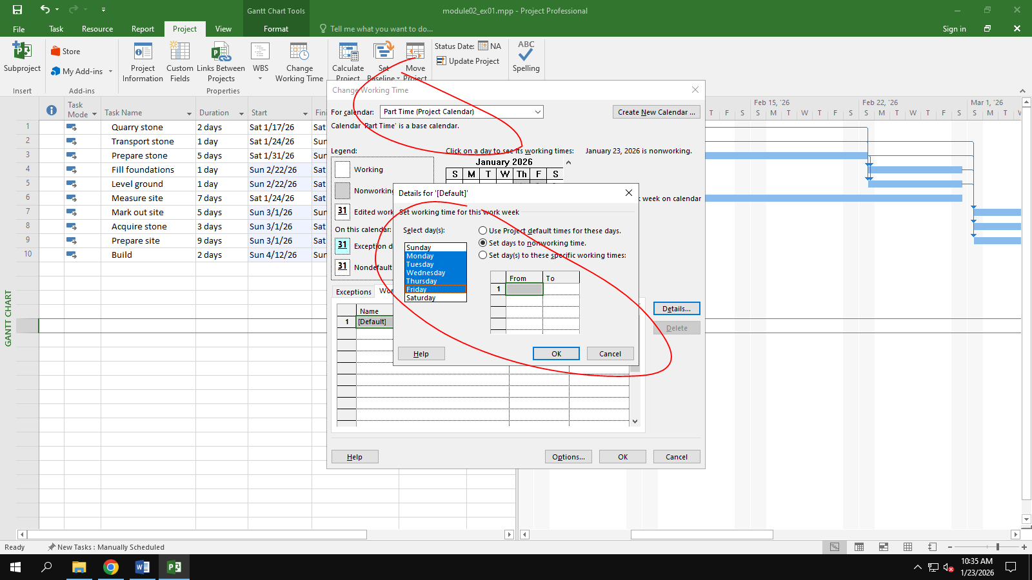

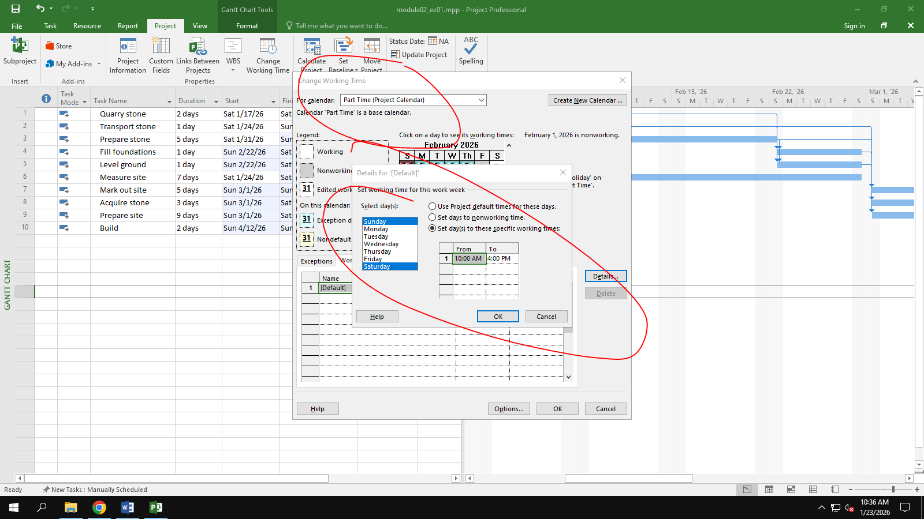

The Part time has also booked a holiday from 1st to Feb 5th . Create an Exception to their calendar with a Holiday name and these days as nonworking

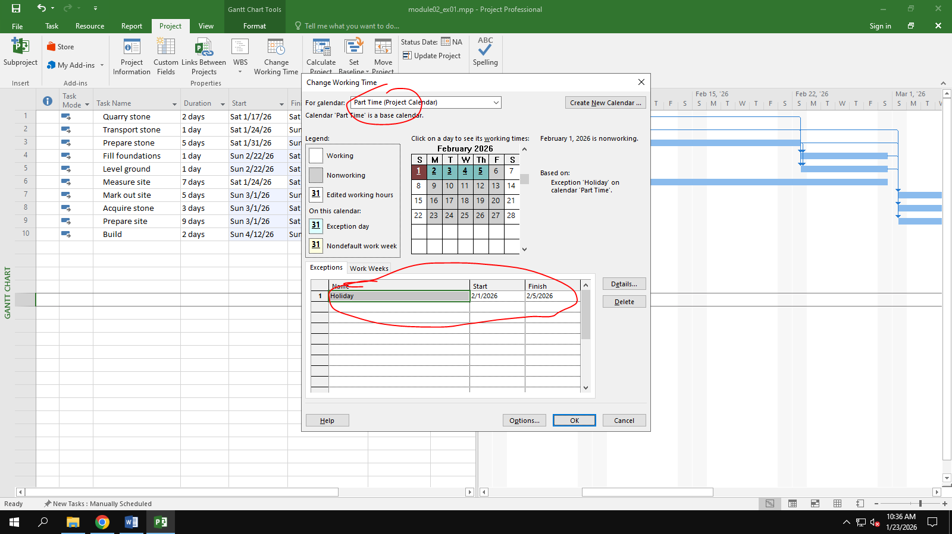

Display the Project Information.

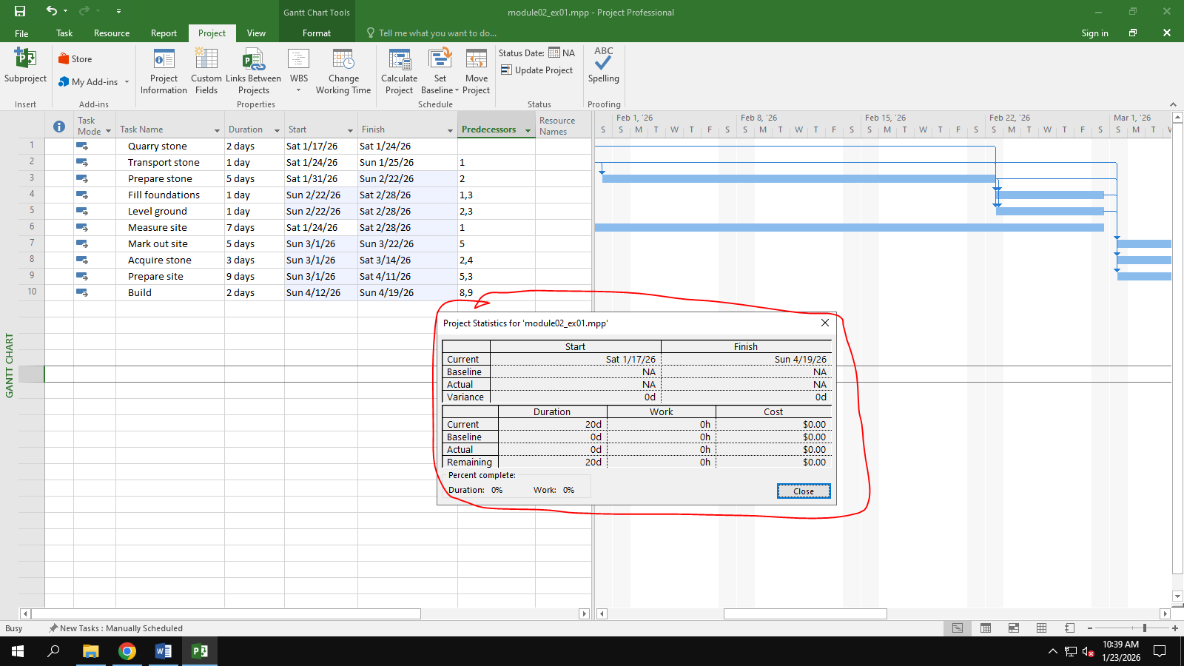

## Exercise 2:

**Changing Working Time**

**Open project file Ex4 (Module 1) Use the Project Information dialog box to:**

Start Date: Nov 20th 2025

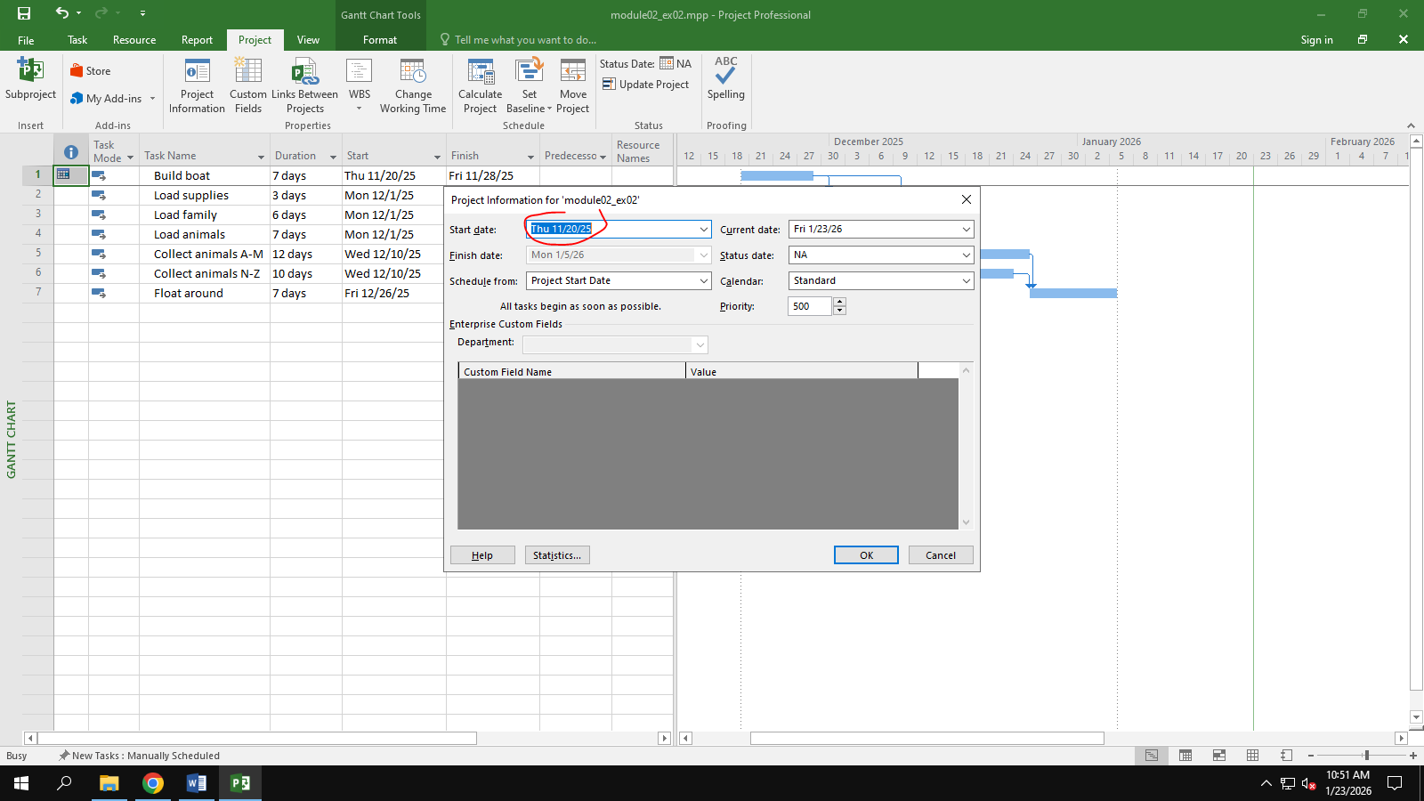

Go to the Change Working Time dialog box and create an Exception called "Tet Holidays" during from Dec 24th 2026 to Jan 5th 2026 into nonworking time.

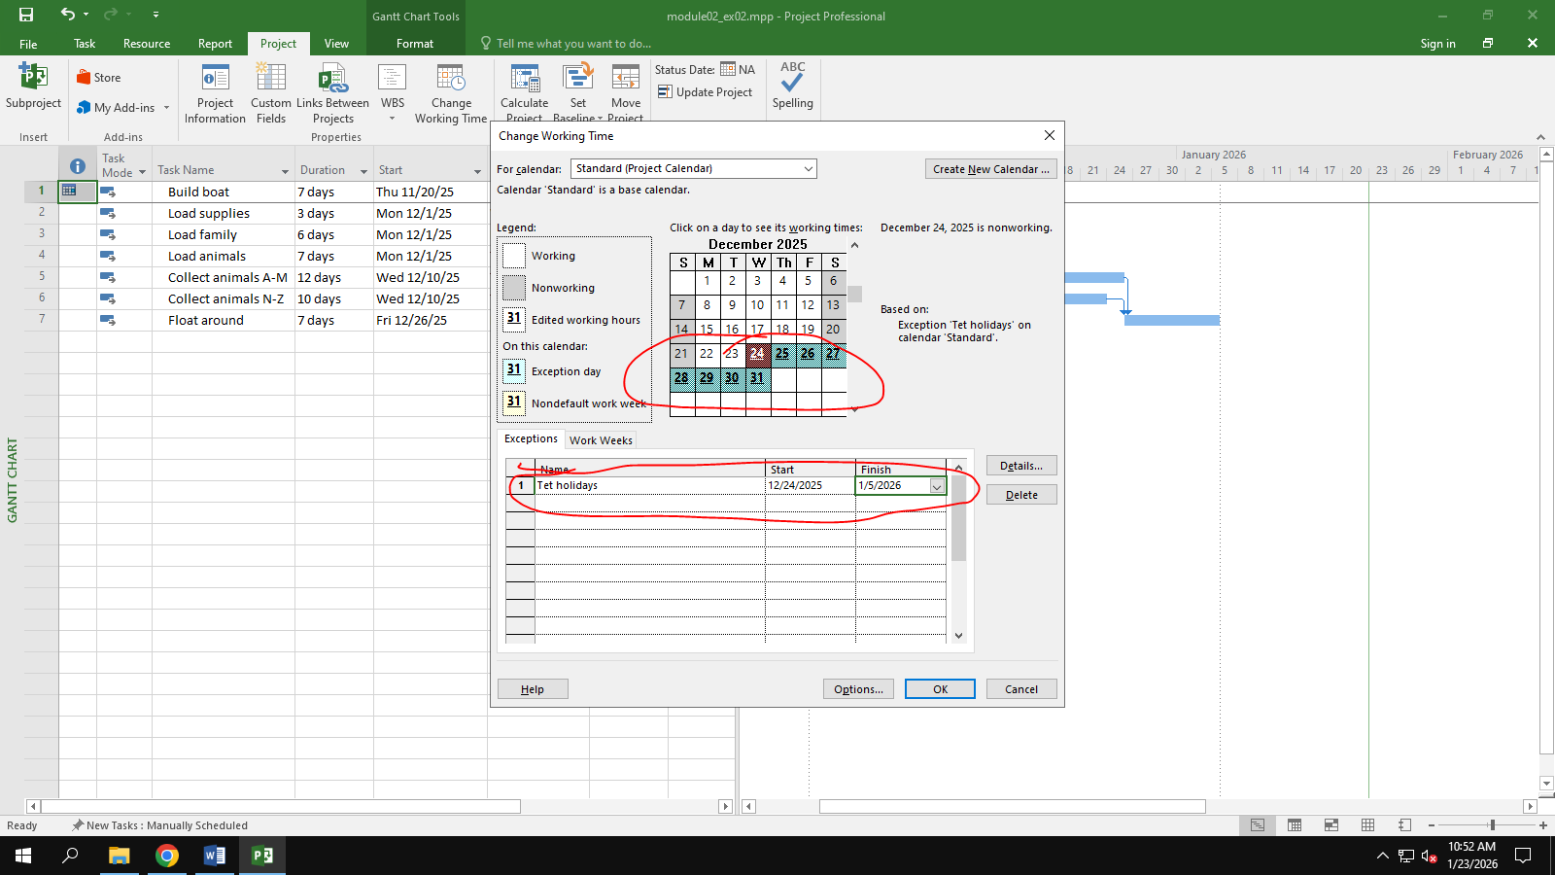

Change Work Weeks time of Standard calendar's default working week. This project's standard working time are:

¬ 08:30 to 17:30 Monday to Thursday (no lunch break)

¬ 08:30 to 16:00 on Fridays (no lunch break)

¬ Add a new Work Week to the Standard calendar named "Xmas Slowdown". Use this to model a 12:30 finish on every weekday from Dec 10th 2025 to Dec 23rd 2025.

¬ Capture the Work weeks time

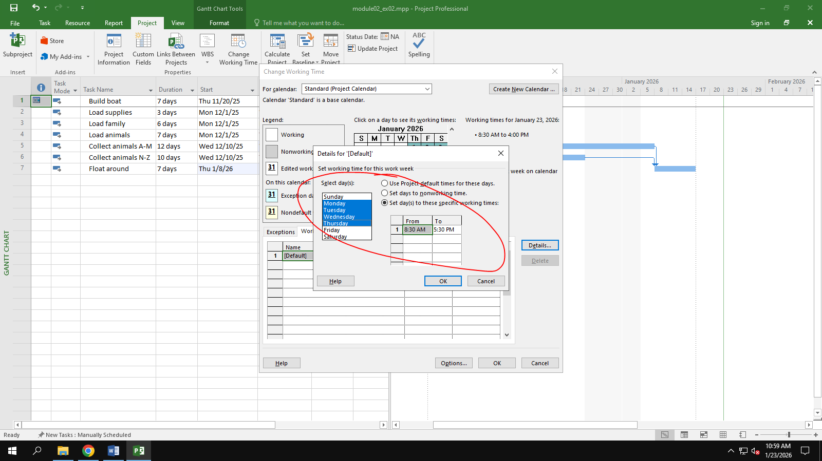

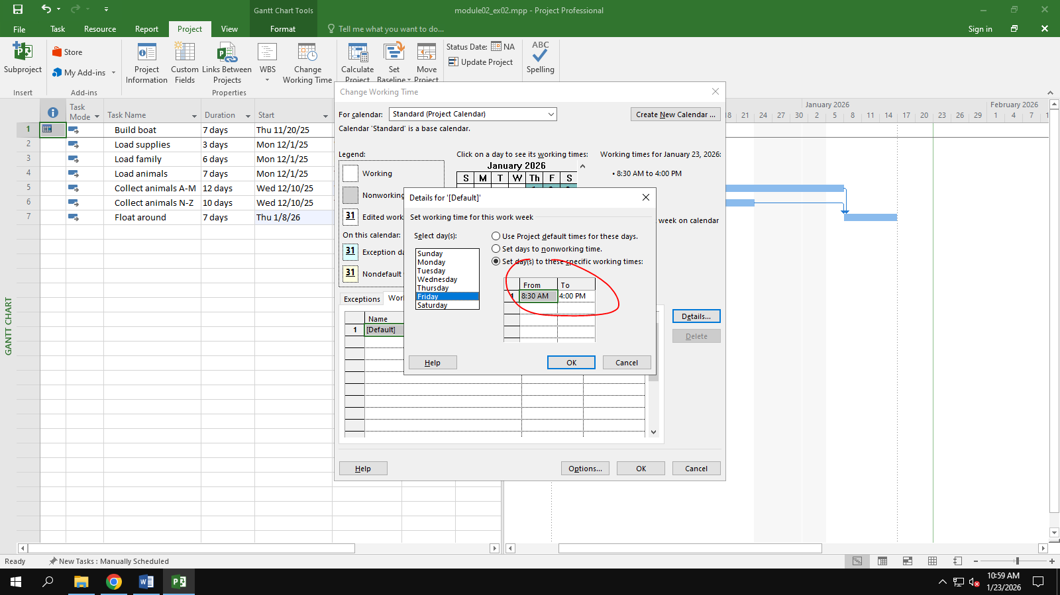

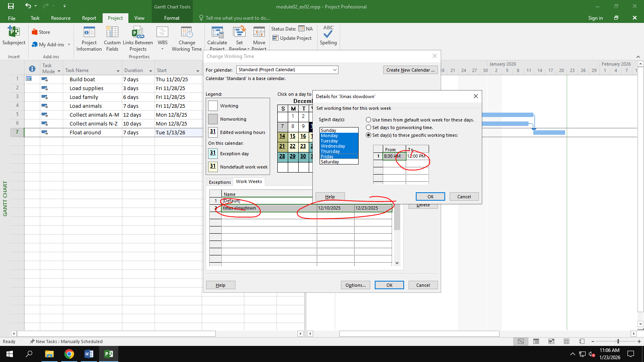

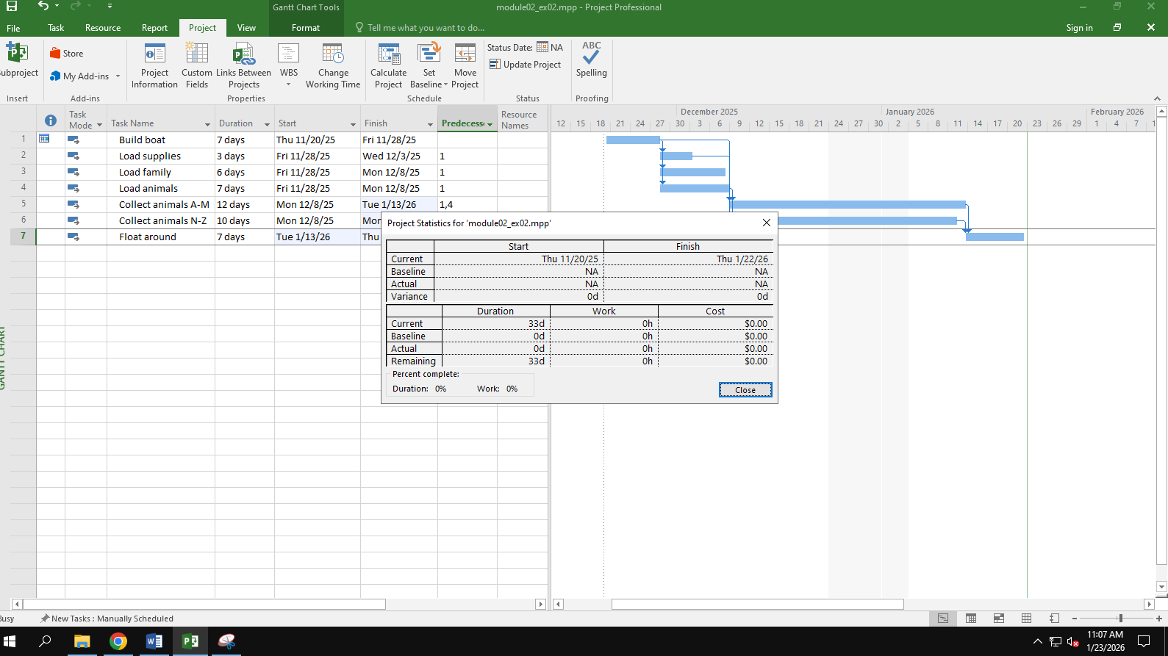

## Exercise 3: example

## Exercise 4: example

## Exercise 5: example

## Exercise 6: example

# Module 3:

## Exercise 1: example

## Exercise 2: example